Creating a Website for the World Language Classroom Using Weebly.com
Charlyn Dalvit
Mount Vernon High School
charlynjohnson@mv.k12.wa.us
www.mountvernonspanish.weebly.com

Objective: Participants will understand the advantages of using Weebly.com to create a class website and will leave the workshop with the published groundwork for their personal website.

Advantages of Weebly.com
- It’s free! The basic service is free—you can have as many webpages as you’d like through the Weebly.com subdomain.
- It’s simple! Weebly.com doesn’t require knowledge of html. Instead, it has a very easy drag-and-drop format that allows you to create an attractive and professional-looking website.
- It’s a great resource for your students! You can upload your original documents for students to access, as well as link to websites with other activities and resources.

Getting started
- Create an account at www.weebly.com.

- Select a theme. Remember, you can change it at any time later (although some formatting, such as font styles, may be lost with the change—but can easily be switched back).

- Select a domain name for your website. If you use a subdomain of Weebly.com, the service is free and you can still have as many webpages as you’d like.

- Select a title for your webpage. This may also be changed later.

Tools and Tabs
- The Build tab
- Drag basic elements to your page: titles, text, text with images, images, galleries, slide shows, contact forms, maps.
- Drag structure elements: columns, dividers, and buttons (that can serve as links).
- Drag media elements: YouTube videos, files and Flash.
- Drag more elements: block quotes, embed codes, polls, social icons, surveys and forums.

- The Design tab
  - Change your website design (background and theme).
  - Change the font.
  - Change the color scheme. You can also change the color of links.

- The Pages tab
  - Add new pages (the three options are standard page, blog page, and external link) and subpages.
Menu button
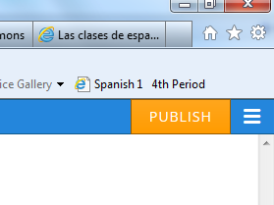
  - Edit advanced settings, such as page html titles, descriptions and meta keywords (search engine words, or tags).

- The Menu button (located at the top right corner of the page)
Publish button
  - Access all of your webpages for editing.

- The Publish button (at the top right corner)
  - As soon as you click here, your webpage is online and live!
Tips
- Some ideas for home page tabs are:
  - Home
  - Classes
  - Resources
  - Culture
  - Travel
  - Opportunities
  - _________________________________________________________________________________________
  - _________________________________________________________________________________________

- Images
  - You can easily upload saved images from your computer. The clipart used on my page is from Creative Commons.
  - Images can be edited (resized), and can also serve as links.

- I created separate webpages (accessible to edit via the Menu button on the top right corner of the page) for each class so that the page title could be the class name.

- On the Pages tab, you can create subpages that appear in a pull-down menu by dragging the page(s) you’d like to be subpages to the right.
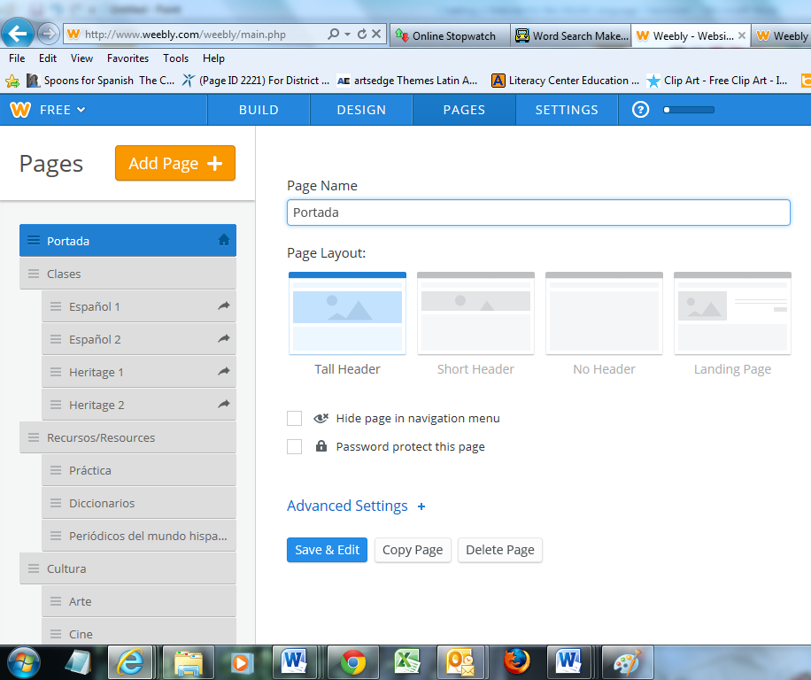

The subpages below Clases are Español 1, Español 2, Heritage 1 and Heritage 2.

- For pull-down menus, it is best to have less than seven or eight items on the menu. If you have more items than that, you can put the links to each item on the main page.

Other Great General Online Resources
- Creative Commons: (www.creativecommons.org) Access free-use graphics and images for your website and classroom.
- Goo.gl: (http://goo.gl/) Create QR codes for web addresses (just paste in the address and click on “Details” on the following page).

- Slideshare: (www.slideshare.net) Share PowerPoints online.

- Thinglink: (www.thinglink.com) Make photos and images more educational! Students can tag photos and images with captions in the target language. (Similar to the images on the bing.com search page.)

- Padlet: (www.padlet.com) A virtual whiteboard for posting information and student work.

- Soundcloud: (www.soundcloud.com) Listen to international music, create your own playlists, and even upload your own (or students’) audio.

- Audioboo: (www.audioboo.com) Create and upload “Boos,” or sound clips.

Notes

